

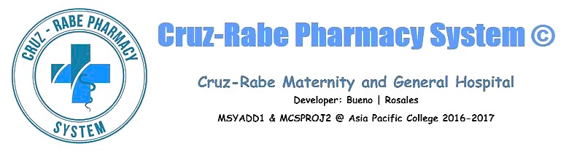

**Developers:**

**Carl Dominique Bueno**

**Glen Roy Rosales**

**CRUZ-RABE PHARMACY SYSTEM**

Cruz-Rabe Maternity and General Hospital

Developer: Bueno | Rosales

MCSPROJ2 @ Asia Pacific College 2016 – 2017

**Project Professor:**

* Mr. Manuel Sebastian Sanchez MSYADD1 Class Professor

**Project Consutant:**

* + Dr. Manuel Calimlim Jr. SoCit Professor
  + Mr. Alfredo Calimbo SoCsit Professor

**Project Adviser:**

* Mr. Jayvee Cabardo Director, Education Technology

**Project Team:**

* Carl Dominique Bueno Project Manager/Developer
* Glen Roy Rosales Project Analyst/Documenter

**Client Information:**

Company/Organization Name: Cruz-Rabe Maternity and General Hospital

Project Name: Cruz-Rabe Pharmacy System

Primary Contact Person: Carmelita Buenaflor

Position: Chief Pharmacists

**Health Facility Detailed Information:**

**ACCREDITATION NO:** H92007290   
**PMCC NO:** 313634   
**INSTITUTION NAME:** Cruz-Rabe Maternity and General Hospital   
**ROAD NAME:** 37 Gen. Luna Street   
**BARANGAY:** Tuktukan   
**MUNICIPALITY:** Taguig City   
**PROVINCE:** Metro Manila (SOUTH)   
**REGION:** NCR (SOUTH)   
**CATEGORY:** Level 2   
**CLASSIFICATION:** Private

# **PROJECT VISION AND SCOPE**

# **Business Requirements**

In order to ensure patient's safety, cost effective processes and well managed admission on managing medical services, through preventing clinical errors and use resources efficiently. Therefore, business process should have a sufficient tool which is an automation of “Pharmacy System.” Transactions that are processed in different factors including; IN and OUT patient order entry, dispensing orders, pharmacy inventory and purchasing management will stand-alone by providing innovative way of service. The client Cruz-Rabe Maternity General Hospital uses the latest technology enabling complete control to improve medical management and to bring satisfaction to their clients in terms of professional service.

## Background

A lot of people are laying their health safety in the hands of medical field professionals, with corresponding good quality equipment, and authorized medicines. These requirements, to ensure to have the right treatment, are all present in the developers’ chosen client; Cruz-Rabe Maternity and General Hospital, accredited as one of the secondary hospital in Taguig City and located at 37 General Luna St., Tuktukan, Taguig City. The hospital itself is a three-storey building that can accommodate 30 bed rooms over 50 patients. Cruz-Rabe Maternity & General Hospital was categorized as a private class hospital in Taguig City and owned by a family corporation. The hospital has associate subsidiaries namely; South Super Highway Medical Centre, the main hospital which can do major unitary operations. And the last one is General Trias Satellite Hospital, which is a gateway hospital in Cavite. These 3 hospitals were owned by Dr. Jose Casimiro Rabe, a family doctor and his wife Dra. Erlinda Cruz Rabe an ob-gyne. Cruz-Rabe Maternity & General Hospital had addressed its main problem particularly on the Pharmacy Booth section and which we think our project team can contribute a solution to their dilemma. Specifically, we proposed a system for the automation of their “Manual Process of Pharmacy Requests.”

A pharmacy within a hospital case, wherein there will only be IN and OUT patients for pharmacy request entry.

## Business Opportunity

Based on the client’s needs, a Pharmacy System will make a huge difference in its line of work. There is sufficient amount of tools to help them do business processes but they are not enough to make it efficient. All transactions being done are in manual type of processing. Because of this, the developers decided to pick an area to develop wherein that factor does a critical role; the pharmacy. The pharmacy of Cruz-Rabe hospital has only two pharmacists, including the developers’ contact, Mrs. Carmelita Buenaflor. Mainly, her concern is the manual way of processing the prescription orders of the patients. Since most likely, a pharmacy request slip needs to be transacted before allowing the patients to leave thus, having another aspect of system because most of the time, the order has already medicines required to be bought before the release. This is where the inventory side comes in. The Pharmacy Request System that will be made can cover all these factors in one place, a big business opportunity which must be done to ensure the efficiency of work especially with limited number of employees.

## Business Objectives and Success Criteria

*Business Objectives*:

* To eliminate undue resources by implementing Paperless Transactions System (PTS) through the use of the system.
* Provides an electronic system that interacts with the patient and the pharmacy.
* Offers convenient way of discharging patients by accumulating valuable records.

*We can assume that the system will be feasible if we meet the following requirements:*

* If the system seems to be helpful when hospital transactions (pharmacy requests) are now processed in just a few moments.
* If the results produced are accurate and reliable for the patients.
* If the pharmacy records can be tracked down easily from its database.
* If less resources are utilized but service would improve.

*We can assume that the system will be successful for a long term if we meet the following requirements:*

* If the system is useful to patients and hospital staffs in terms of service, performance and satisfaction.
* If it will generate enough revenue to support the maintenance of the system.

## Customer or Market Needs

Our client’s previous business processes particularly in pharmacy transaction uses manual way of requesting and dispensing orders to the patient. However, discharging also took time and resources before the releasing. Therefore, our project team proposed a system that targets anyone who needs prescription medication or other health-related products and identifying the different types of patients who make purchases at the pharmacy. Defining the pharmacy’s target on satisfaction of service and lessen the time of processes, the system will be able to streamline the business transactions by ordering the right products and payments in a more efficient manner.

## Business Risks

In operation of the system, it might take in critics since the pharmacy department will be adapting changes towards its business transactions. Therefore, it will require equipment and additional services in order to produce the system. This means, the organization need to invest in this project as there is a possibility to make changes in certain aspects such as its maintenance and security.

# **Vision of the Solution**

Our vision is for pharmacy processes to play its part in improving quality in pharmacy performance and services. Patients may assume the automation of processing the prescription and demand on discharging patients.

## Vision Statement

A Web-based system for processing pharmacy request within a system, dedicated to ease the way of accepting requests by pharmacists to process the automated prescription orders and dispense orders in a better way. It will not only verify the information received, but also keep the records in a secured database which can be accessed for future preferences. Unlike the old-way of manual processes, Cruz-Rabe Pharmacy Request System intends to improve the quality of work in the medical field by providing the essential steps of transactions in fast-pace. The vision of this system is determined to meet patient’s satisfaction in terms of service.

## Major Features

The Pharmacy Request System offers the following features:

* Convenient way of purchasing Medicine and Supplies within the pharmacy.
* Can easily do inventory check for tracking down changes on stocks.
* Discharging patients with electronic records.
* Checks the validation and availability of the requests.
* Secures the authorization of the pharmacists and authorized personnel to do the process.
* Sends the information throughout the other departments electronically.

## Assumptions and Dependencies

AS-1: Additional equipment, services, and maintenance will be improvised for the authorized personnel to do the business processes.

AS-2: The hospital will be developed to ensure the system was implemented well-lesser hardcopies, more softcopies for the records.

DE-1: If the pharmacy records will be accessible with the other departments to support the system for consistency of the data.

# **Scope and Limitations**

Pharmacy Request System is intended for pharmacists to use in their service that assists patients’ drug requests that is prescribed by a doctor. The patients will present their prescription given by the doctor into the nurse that will be processed by the pharmacist. The pharmacist will do request of orders that will be paid upon the cashier and billing section. Once the orders are paid, the orders will be ready to dispense to the patient. Alternatively, the Pharmacy Requests will be automated and the data will be on a database for data warehouse. On discharging In-Patients will be provided with their records as fast as possible. The stocks they took will be listed down on their records in real time. Therefore, in paying their bills, the process will take lesser time. This scheme will ease the work of the auditing staff and improve the discharging process of patients.

## Limitations and Exclusions

The Cruz-Rabe Pharmacy Request System will be having a paperless transaction. The departments are linked to provide services to the patient. The system will also provide records for the discharging patient.

# **Business Context**

## Stakeholder Profiles

|  |  |  |  |  |
| --- | --- | --- | --- | --- |
| **Stakeholder** | **Major Value** | **Attitudes** | **Major Interests** | **Constraints** |
| Pharmacists | Has the key role in the entire business transaction on processing the prescription for request of patients. | Determined to bring the best production in pharmacy, concern in the development of the following areas. | Job preservation, service satisfaction. | Brief practice on the new scheme of business process. |
| Doctors | Serves as the source of pharmacy transactions. | Checks and issues prescription for the patient. | Patient Prescriptions will be only validated by pharmacists | No prescription, no request. |
| Patients | The primary client of the system. | Interaction with the doctor, nurse and pharmacists on pharmacy transaction. | Ease of way of dispense of orders and discharge. | Implementation of the system. |
| Nurse | Offers service and assistance to the client | Assist the patient of processing request. | Serves patient on their demands and requests | Service on patient |
| Cashier/  Billing | Functions on financial aspects and records of the client. | Receives payment and Issues receipt for the client. Release discharge record of the patient | Make all things credited and validated | Purchased items and payments will be logged for discharge. |

## Project Priorities

|  |  |  |  |
| --- | --- | --- | --- |
| **Dimension** | **Driver (state objective)** | **Constraint (state limits)** | **Degree of Freedom (state allowable range)** |
| Schedule | release 1.0 to be available by 10/14/16, the next release for version to will be on 10/18/16. The release of the final version will be on month of December 2016. | Time constraints | none |
| Features | The system provides services to the patient | none | 70-80% of high priority features must be included in release 1.0 |
| Quality | CRPRS provides satisfaction to the client | Bugs and Errors | 90-95% of user acceptance tests must pass for release 1.0, 95-98% for release 1.1 |
| Staff | The project team were able to meet the demands of the client. | maximum team size is 6 developers + 4 testers | none |
| Cost | The cost of the project depends on the feature of the system. It must be supported by the client. | Budget of the organization | budget overrun up to 15% acceptable without executive review |

## 

## Operating Environment

The deployment of the system will be successful if it meets the following criteria:

* Stable network connection from the nurse station to pharmacy department up to billing section.
* Computers and other peripherals are working and maintained properly to prevent occurrence of technical interruptions.
* The users (pharmacists, nurse, cashier) are capable to use system.
* Utilizing authorization protocols to secure usage of the system.

1. **STATEMENT OF WORK**

## Introduction

Cruz-Rabe Maternity and General Hospital has recently sponsored a system for their Pharmacy inside the hospital by students for their course project. It is called Cruz-Rabe Pharmacy Request System. It is a system where the admin or operator can track all the flows related to pharmacy. CRPRS will focus on tracking expenses and point of sales of the pharmacy. It will be more efficient since the pharmacy will now have a system where all activities inside pharmacy will less work flows. The said system on the pharmacy will do inside works like database for inventory where the operator will not use paper works anymore which they find inconvenience at work. It also gives less time to process a customer order. As for new developments, CRPRS will find it helpful for them to work because of less time for flow of processes and easy to track the inventory inside pharmacy.

# **Scope of Work**

The scope of work for the CRPRS includes all planning, execution, implementation, and training for a new public-facing a technology. The selected pharmacist will be responsible for operating the new system provided by students. Each stage of the project will require approval from Cruz-Rabe management before moving on to the next stage. The selected developer must ensure it has adequate resources for designing, building, testing, and implementing the new system site and is staffed for the training of pharmacist or other personnel as well to monitor and operate the system well. Specific deliverables and milestones will be listed in the Database of the work of flows sections of this SOW.

# **Period of Performance**

The period of performance for the CRPRS is one year (365 days) beginning when project finished and it will be a testing to know if the system is successful. All work must be scheduled to complete within this timeframe. Any modifications or extensions will be requested through Cruz-Rabe Management contracting officers for review and discussion.

# **Place of Performance**

The selected pharmacist for the Cruz-Rabe Pharmacy Request System will perform a majority of the work at its own facility inside the hospital. The pharmacist will be required to meet at Cruz-Rabe facility every day since it is a Hospital. Additionally, all project gate reviews will be held at Cruz-Rabe Management facility and attended by the pharmacist. Cruz-Rabe will provide and arrange for meeting spaces within its facility for all required pharmacist meetings. Once the project reaches the training phase, all training will be conducted at Cruz-Rabe facility.

# **Work Requirements**

As part of the Cruz-Rabe Pharmacy Request System, the Students will be responsible for performing tasks throughout various stages of this project. The following is a list of these tasks which will result in the successful completion of this project:

# **Kickoff:**

* Students will create and present detailed project plan including schedule, testing plan, implementation plan, training plan, and transition plan
* Students will present project plan to Cruz-Rabe Management for review and approval

# **Design Phase:**

* Work with the management to gather requirements and establish metrics
* Create system design based on collected requirements
* Develop site design proposal for Cruz-Rabe Management and review and approval
* Present written status at weekly meeting

**Build Phase:**

* Students will complete all coding for approved site design
* Students will provide the management with a detailed testing plan
* Students will include all content provided by the management on redesigned system

Students will resolve any coding and site issues identified in testing

* Students will compile a testing report to present to the Management for review/approval
* Present written status at weekly meeting

**Implementation Phase:**

* Students will implement the newly redesigned system on Management servers
* Students will begin providing 24x7 system support at this point forward until the end of the period of performance
* Present written status at weekly meeting

**Training Phase:**

* Management will provide training in accordance with approved training plan provided in the kickoff
* Present written status at weekly meeting

**Project Handoff/Closure:**

* Vendor will provide SCG with all documentation in accordance with the approved project plan
* Vendor will present project closure report to SCG for review and approval
* Vendor will complete the project requirements checklist showing that all project tasks have been completed
* Vendor will conclude 24x7 web support at 11:59pm on the final day of the period of performance
* Present written status at weekly meeting

# **Schedule/Milestones**

The below list consists of the initial milestones identified for the Website Redesign Project:

*RFP/SOW Release* January 2, 20xx

*Vendor Selection Review*  February 1-28, 20xx

*Vendor Selection*  March 1, 20xx

*Period of Performance Begins* March 2, 20xx

*Website Design Review* August 31, 20xx

*Website Implementation Review* November 30, 20xx

*Implementation Complete* December 31, 20xx

*Training Complete*  February 20, 20xx

*Project Completion Review* February 25, 20xx

*Project Closure/Archives Complete* March 3, 20xx

# **Acceptance Criteria**

For the Website Redesign Project the acceptance of all deliverables will reside with SCG’s Vice President of Marketing. The VP of Marketing will maintain a small team of three advisors in order to ensure the completeness of each stage of the project and that the scope of work has been met. Once a project phase is completed and the vendor provides their report/presentation for review and approval, the VP of Marketing will either sign off on the approval for the next phase to begin, or reply to the vendor, in writing, advising what tasks must still be accomplished.

Once all project tasks have been completed, the project will enter the handoff/closure stage. During this stage of the project, the vendor will provide their project closure report and project task checklist to SCG’s VP of Marketing. The acceptance of this documentation by SCG’s VP of Marketing will acknowledge acceptance of all project deliverables and that the vendor has met all assigned tasks.

Any discrepancies involving completion of project tasks or disagreement between SCG and the chosen vendor will be referred to both organizations’ contracting offices for review and discussion.

# **Other Requirements**

All vendor project team members will submit security forms to SCG for clearance and access badges to the facility. All vendor programmers and quality control team members will be granted access to SCG servers and all necessary IT functions. They will also be given temporary SGC accounts which are to be used only for work pertaining to the Website Redesign Project. Upon completion of the project these accounts will be closed.

All programming and testing will be done in the iLab. A network outage will be scheduled for the implementation phase of this project. Prior to the network outage, all servers will be backed up and a notification will be distributed to all users.

1. **GANTT CHART**

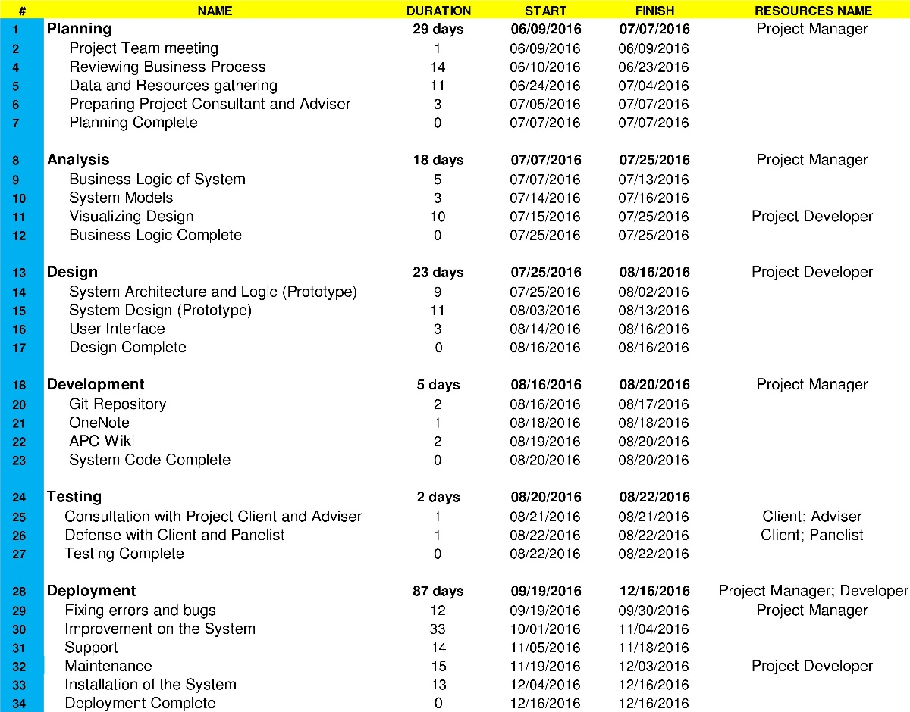

1. **WORK-BREAKDOWN STRUCTURE**

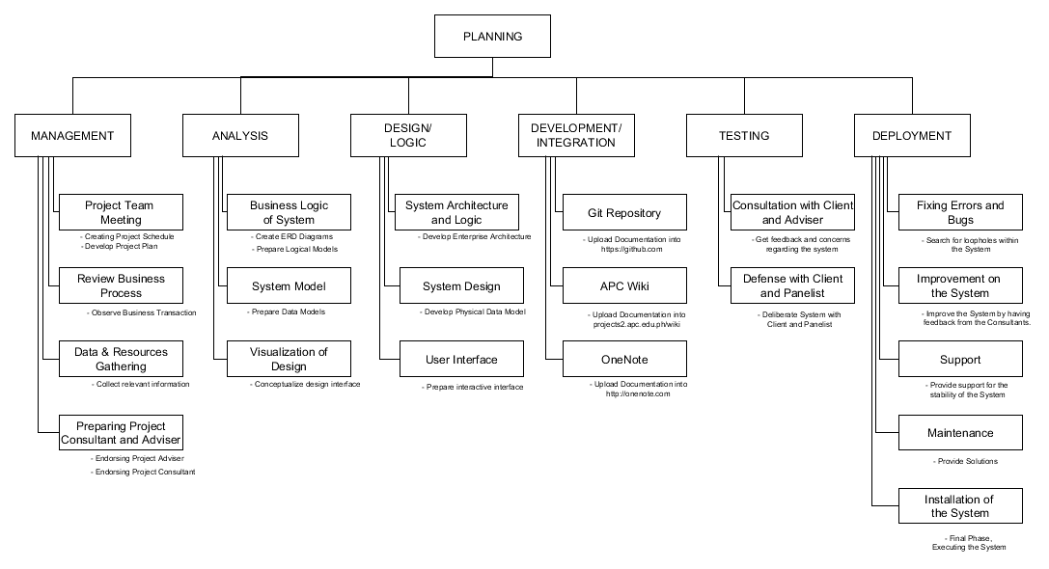

1. **ACTIVITY LIST**

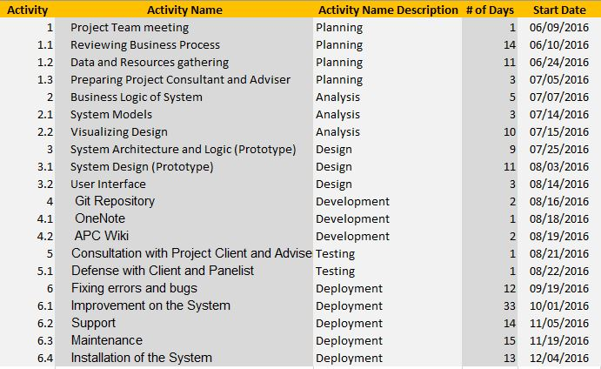

1. **SYSTEM REQUIREMENTS SPECIFICATION**

**Introduction**

* 1. **Purpose**

The *System Requirements Specification* (SRS) document is intended to provide detailed overview of our software product, therefore, its constraints and goals. Our sponsored client, Cruz-Rabe Maternity and General Hospital, given us the opportunity to build a system wherein its scope is within pharmacy transactions of the hospital, including the interactions of patient and the management itself. The system from which we are building to provide convenient and more efficient in resources, namely *Cruz-Rabe Pharmacy Request System*.

The purpose of this document is to discuss how the system works, its functionalities and its features. Therefore, the developers will use this document as a guide to completely comprehend the requirements to build and integrate the software.

* 1. **Document Conventions**

Software Requirement Specification document is published on Microsoft Word 2016, using font “Times New Roman” and font size of “12dp” for context and 14dp” for headings and titles with Bold font styles.

This document has six (6) parts with sub-topics, namely:

1. Introduction
2. Overall Description
3. External Interface Requirements
4. System Features
5. Other Nonfunctional Requirements
6. Other Requirements
   1. **Intended Audience and Reading Suggestions**

Involve readers that were participated to the project:

* *Project Manager -*
* *Developers -*
* *Project Adviser -*
* *Project Consultant -*
* *Project Client -*
* *Hospital Pharmacist -*
* *Nurse -*
* *Billing/Cashier -*
* *Patient -*

**1.4 Product Scope**

Pharmacy Request System is intended for pharmacists to use in their service that assists patients’ drug requests that is prescribed by a doctor. The patients will present their prescription given by the doctor into the nurse that will be processed by the pharmacist. The pharmacist will do request of orders that will be paid upon the cashier and billing section. Once the orders are paid, the orders will be ready to dispense to the patient. Alternatively, the Pharmacy Requests will be automated and the data will be on a database for data warehouse. On discharging In-Patients will be provided with their records as fast as possible. The stocks they took will be listed down on their records in real time. Therefore, in paying their bills, the process will take lesser time. This scheme will ease the work of the auditing staff and improve the discharging process of patients.

**2.1 Product Functions**

Based on the user and software function:

*DOCTOR*

* check-up patient (in and out patient)
* create prescription for the patient (in and out patient)

*NURSE*

* create a request based on the prescription coming from the doctor
* distribute order/s to in-patient
* process the discharge request slip of in-patient.

*PHARMACY*

* check for the prescription’s validity (if the drug or supply is necessary to give to patients)
* check the availability of orders and its effectivity
* approve the request charge slip
* prepare orders for dispense to patients

*PATIENT*

* present prescription to the pharmacy for out-patient
* admit to the hospital if in-patient
* confirm order/s before processing
* take necessary and available medicine and supply upon request

*BILLING & CASHIER*

* confirm corresponding amount before generating to the system
* process service and order charge/s for in-patient for discharge clearance
* accept payment of orders from the patient
* generate official receipt

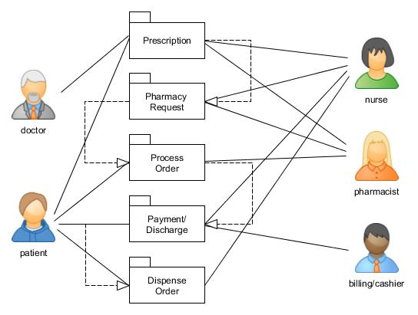

**2.3 User Classes and Characteristics**

*The first hand user of Cruz-Rabe Pharmacy Request* System is the hospital pharmacist. The system should only interact with a licensed pharmacist with sufficient knowledge on the software.

The first person user should consist of the following characteristic:

* Licensed pharmacist
* Computer-literate
* Can interact with the user interface and know how the system works
* Can do basic software operations
* Have knowledge on troubleshooting

**2.4 Operating Environment**

The system will run and be supported by the following:

* [Core 2 Duo](https://en.wikipedia.org/wiki/Core_2_Duo) or [Athlon X2](https://en.wikipedia.org/wiki/Athlon_X2) at 2.4 GHz or Higher
* At least 2GB of RAM
* 30GB of ROM or Higher
* Network Connection
* Windows 10 or Later
* Internet Browser (Google Chrome, Mozilla Firefox, etc)
* PHP
* MySQL
* XAMPP Control Panel

**2.7 Assumptions and Dependencies**

**AS-1:** Additional equipment, services, and maintenance will be improvised for the authorized personnel to do the business processes.

**AS-2:** The hospital will be developed to ensure the system was implemented well-lesser hardcopies, more softcopies for the records.

**DE-1:** If the pharmacy records will be accessible with the other departments to support the system for consistency of the data.

**3.2 Hardware Interfaces**

* [Core 2 Duo](https://en.wikipedia.org/wiki/Core_2_Duo) or [Athlon X2](https://en.wikipedia.org/wiki/Athlon_X2) at 2.4 GHz or Higher
* At least 2GB of RAM
* 30GB of ROM or Higher
* Network Connection and Peripherals
* Mouse
* Keyboard
* Printer/Copier Machine

**3.3 Software Interfaces**

* Windows 10 or Later
* Internet Browser (Google Chrome, Mozilla Firefox, etc.)
* PHP
* MySQL
* XAMPP Control Panel

1. **CHANGE MANAGEMENT PLAN**

# **Introduction**

The Change Management Plan was created for the Cruz-Rabe Pharmacy Request System Project in order to set expectations on how the approach to changes will be managed, what defines a change, the purpose and role of the change control board, and the overall change management process. All stakeholders (Client, Project Team, Adviser, Consultant) will be expected to submit or request changes to the CRPRS Project in accordance with this Change Management Plan and all requests and submissions will follow the process detailed herein.

# **Change Management Approach**

The Change Management approach for the CRPRS Project will ensure that all proposed changes are defined, reviewed, and agreed upon so they can be properly implemented and communicated to all stakeholders. This approach will also ensure that only changes within the scope of this project are approved and implemented.

The Change Management approach is not to be confused with the Change Management Process which will be detailed later in this plan. The Change Management approach consists of three areas:

* Ensure changes are within scope and beneficial to the project
* Determine how the change will be implemented
* Manage the change as it is implemented

The Change Management process has been designed to make sure this approach is followed for all changes. By using this approach methodology, the CRPRS Project Team will prevent unnecessary change from occurring and focus its resources only on beneficial changes within the project scope.

# **Definitions of Change**

There are several types of changes which may be requested and considered for the CRPRS Project. Depending on the extent and type of proposed changes, changes project documentation and the communication of these changes will be required to include any approved changes into the project plan and ensure all stakeholders are notified. Types of changes include:

* Scheduling Changes: changes which will impact the approved project schedule. These changes may require fast tracking, crashing, or re-baselining the schedule depending on the significance of the impact.
* Budget Changes: changes which will impact the approved project budget. These changes may require requesting additional funding, releasing funding which would no longer be required, or adding to project or management reserves. May require changes to the cost baseline.
* Scope Changes: changes which are necessary and impact the project’s scope which may be the result of unforeseen requirements which were not initially planned for. These changes may also impact budget and schedule. These changes may require revision to WBS, project scope statement, and other project documentation as necessary.

The project manager must ensure that any approved changes are communicated to the project stakeholders. Additionally, as changes are approved, the project manager must ensure that the changes are captured in the project documentation where necessary. These document updates must then be communicated to the project team and stakeholders as well.

# **Change Control Board**

The Change Control Board (CCB) is the approval authority for all proposed change requests pertaining to the CRPRS Project. The purpose of the CCB is to review all change requests, determine their impacts on the project risk, scope, cost, and schedule, and to approve or deny each change request. The following chart provides a list of the CCB members for the CRPRS Project:

|  |  |  |
| --- | --- | --- |
| **Name** | **Position** | **CCB Role** |
| Carmelita D. Buenaflor | Project Client | CCB Chair |
| Carl Dominique P. Bueno | Project Manager | CCB Member |
| Glen Roy D. Rosales | Project Analyst | CCB Member |
| Jayvee Cabardo | Project Adviser | CCB Co-chair |
| Alfred Calimbo | Project Consultant | CCB Co-chair |
| Manny Calimlim | Project Consultant | CCB Co-chair |

As change requests are submitted to the CRPRS Project Manager by the project team/stakeholders, the Project Manager will log the requests in the change log and the CCB will convene every other Friday to review all change requests. For a change request to be approved, all CCB members must vote in favor. In the event more information is needed for a particular change request, the request will be deferred and sent back to the requestor for more information or clarification. If a change is deemed critical, an ad hoc CCB meeting can be called in order to review the change prior to the next scheduled bi-weekly CCB meeting.

# **Roles and Responsibilities**

The following are the roles and responsibilities for all change management efforts related to the CRPRS Project:

***Project Client:***

* Approve all changes to budget/funding allocations
* Approve all changes to schedule baseline
* Approve any changes in project scope
* Chair the CCB

***Project Manager****:*

* Receive and log all change requests from project stakeholders
* Conduct preliminary risk, cost, schedule, scope analysis of change prior to CCB
* Seek clarification from change requestors on any open issues or concerns
* Make documentation revisions/edits as necessary for all approved changes
* Participate on CCB

***Project Team/Adviser/Consultants:***

* Submit all change requests on standard organizational change request forms
* Provide all applicable information and detail on change request forms
* Be prepared to address questions regarding any submitted change requests
* Provide feedback as necessary on impact of proposed changes
* Gives advice what step should take to have a proper process
* Participate on CCB

# ***Change Control Process***

The Change Control Process for the CRPRS Project will follow the organizational standard change process for all projects. The project manager has overall responsibility for executing the change management process for each change request.

1. Identify the need for a change (Stakeholders) – Change requestor will submit a completed change request form to the project manager.
2. Log change in the change request register (Project Manager) – The project manager will keep a log of all submitted change requests throughout the project’s lifecycle.
3. Evaluate the change (Project Manager, Team, Requestor) – The project manager will conduct a preliminary analysis on the impact of the change to risk, cost, schedule, and scope and seek clarification from team members and the change requestor.
4. Submit change request to CCB (Project Manager) – The project manager will submit the change request, as well as the preliminary analysis, to the CCB for review.
5. Obtain Decision on change request (CCB) – The CCB will discuss the proposed change and decide whether or not it will be approved based on all submitted information.
6. Implement change (Project Manager) – If a change is approved by the CCB, the project manager will update and re-baseline project documentation as necessary.

**IX. QUALITY PLAN**

**Introduction**

This document specifies the standards, responsibilities and specification of activities to ensure the quality and feasibility of the project. Quality goals and plans are integrated with overall strategic plans of the sponsored organization. As the projects, Cruz-Rabe Pharmacy Request System, consists of applicable procedures, applicable workmanship standards, the measurement tolerances acceptable, the description of the material standards and so forth.

Quality plan is also represented with other relevant document. Quality plans is defined as:

* Specific documents that are relevant to guarantee standards for further procedure and operation.
* Implementation should be able to meet the project objectives.
* Suitable testing, inspection, examination, and audit programs at appropriate stages
* A documented procedure for changes and modifications to a quality plan as a process is improved

**Project Contractual Information**

|  |  |
| --- | --- |
| **Project:** | Cruz-Rabe Pharmacy Request System |
| **Project Number:** | 106 |
| **Program Co-ordinator:** | Mrs. Carmelita Buenaflor |
| **Principal Investigator(s):** | Mr. Manuel Sebastian Sanchez |

**Scope of Work and Quality Objectives**

|  |  |
| --- | --- |
| *Scope of work:* | Pharmacy Request System is intended for pharmacists to use in their service that assists patients’ drug requests that is prescribed by a doctor. The patients will present their prescription given by the doctor into the nurse that will be processed by the pharmacist. The pharmacist will do request of orders that will be paid upon the cashier and billing section. Once the orders are paid, the orders will be ready to dispense to the patient. Alternatively, the Pharmacy Requests will be automated and the data will be on a database for data warehouse. On discharging In-Patients will be provided with their records as fast as possible. The stocks they took will be listed down on their records in real time. Therefore, in paying their bills, the process will take lesser time. This scheme will ease the work of the auditing staff and improve the discharging process of patients. |
| *QA Requirement:* | Software evaluation  Reviewing deliverables  Project testing (client and subjects)  Error and Bug reports  Having feedbacks and reviews |

**Project Organization**

|  |  |
| --- | --- |
| Project Manager(s): | *Carl Dominique Bueno* |
| Task Manager(s): | *Glen Roy Rosales* |
| Quality Assurance: | *Carl Dominique Bueno* |
|  |  |
| Other Team Members: | *none* |
| Subcontractors: | *none* |
| User Community: | *Mrs. Carmelita Buenaflor*  *(Chief Pharmacists/Client)* |
| Technical Reviews: | *Mr. Jayvee Cabardo (project adviser)*  *Mr. Manuel Calimlim (project consultant)*  *Mr. Alfred Calimbo (project consultant* |

**Project Duration and Scheduling**

|  |  |  |  |
| --- | --- | --- | --- |
| Start Date: | June 13, 2016 *(starting from MSYSADD1)* |  | |
| Completion Date: | December 14, 2016 *(end of CSPROJ2)* |  | |
| Scheduling of Activities | | |  | |  |

**Deliverables**

Deliverables specified for the project include:

1. An acceptable Quality Plan
2. An acceptable Data Management Plan
3. An acceptable Project Documentation including models (tables & diagrams)
4. An acceptable Project Plan
5. An acceptable Work Breakdown Statement
6. An acceptable Statement of Work Document
7. An acceptable Gantt Chart and Activity List Model
8. An acceptable Scope and Vision Document
9. An acceptable Software Requirements Specification Document
10. An acceptable Change Management Plan
11. An acceptable Project Progress Reports

**Document and Record Control**

Project documents, progress reports, data models and software variables on previous and current works: INTSDEV, MSYSADD1 and MCSPROJ2 are compiled and distributed to GIT repository, OneNote, APC Wiki and Bluemix Cloud.

**Entity-Relationship Diagram**

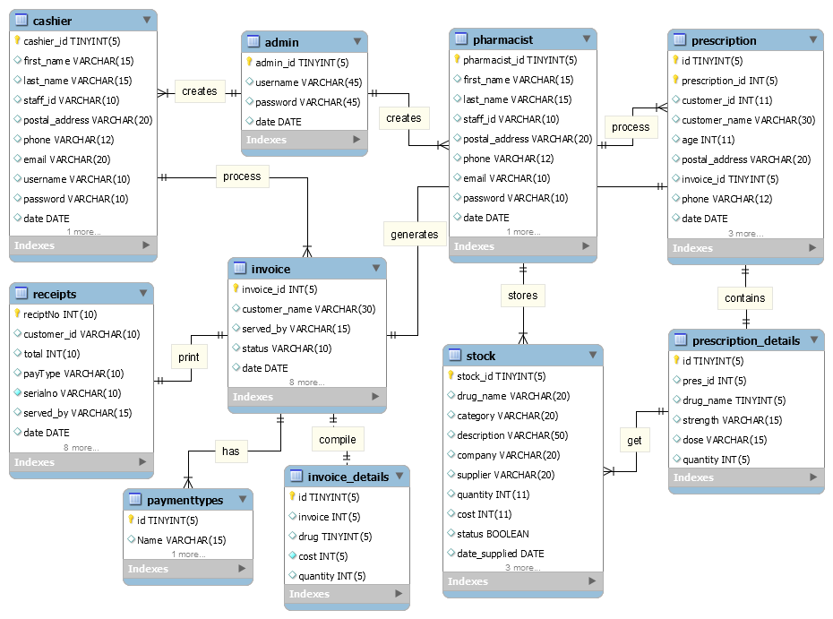

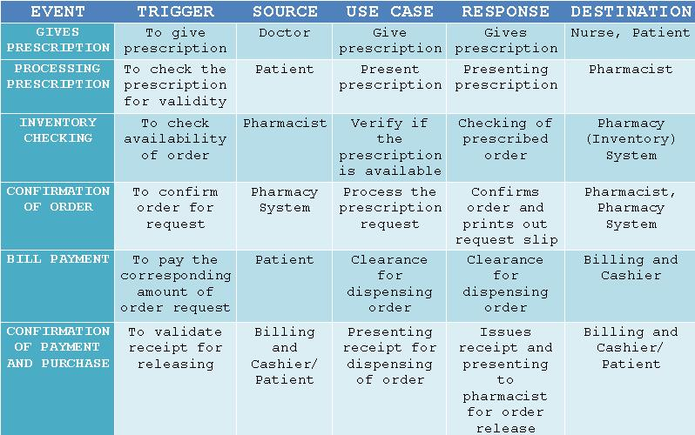**Event Table**

**USE CASE FULL DEFINITION**

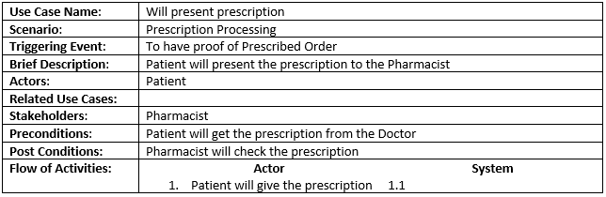

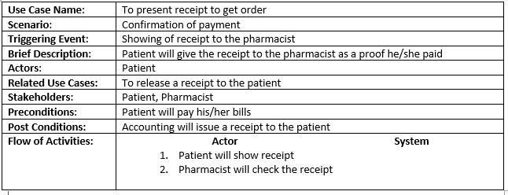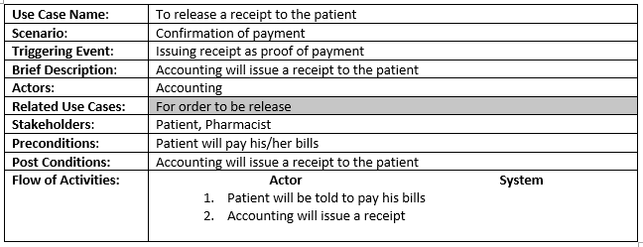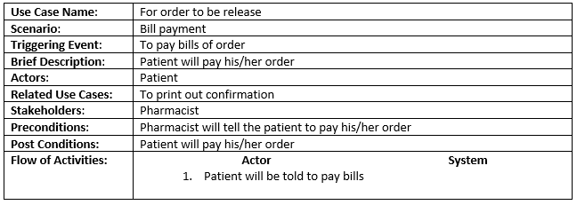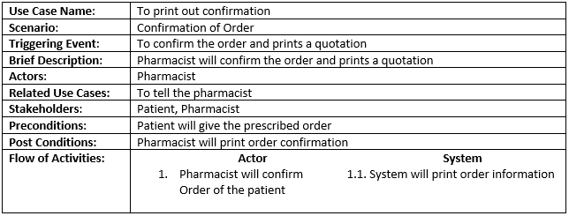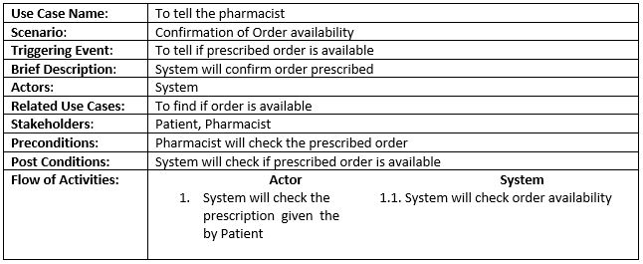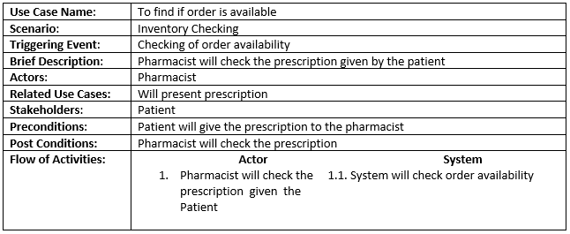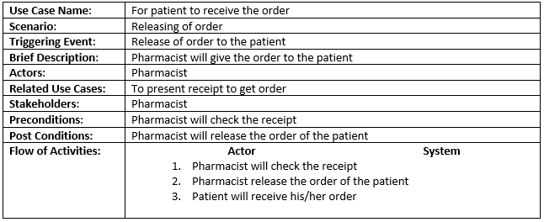

**ACTIVITY DIAGRAM**

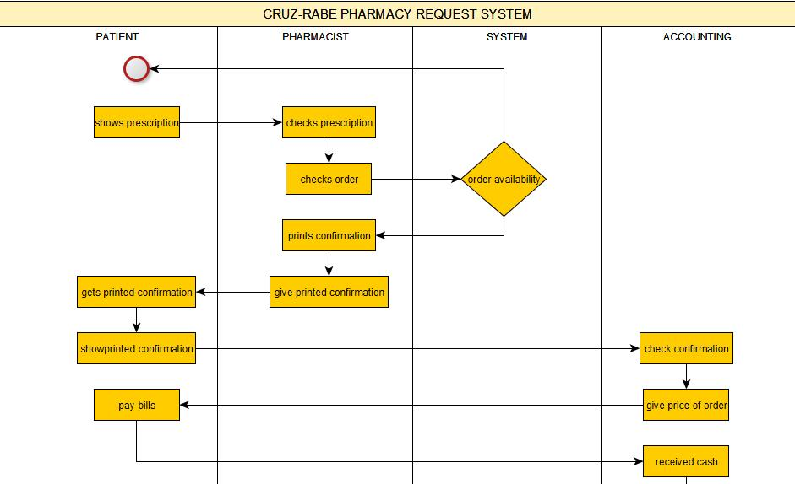

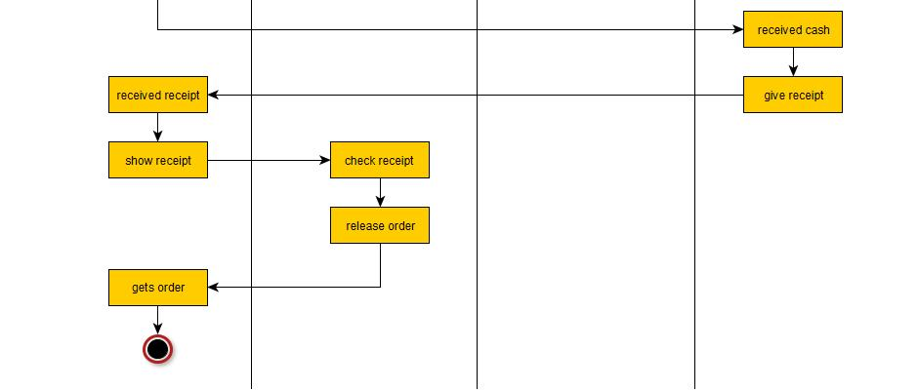

**CLASS DIAGRAM**

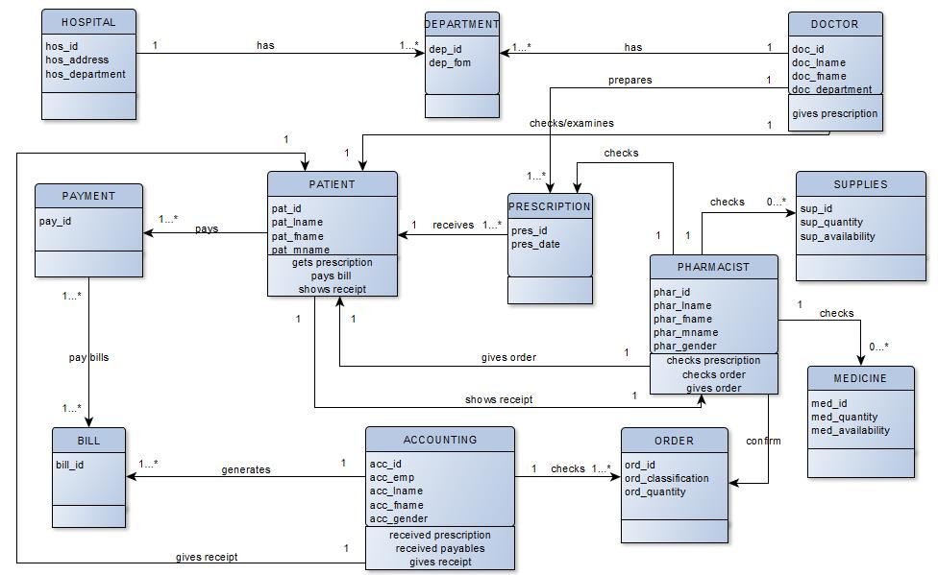

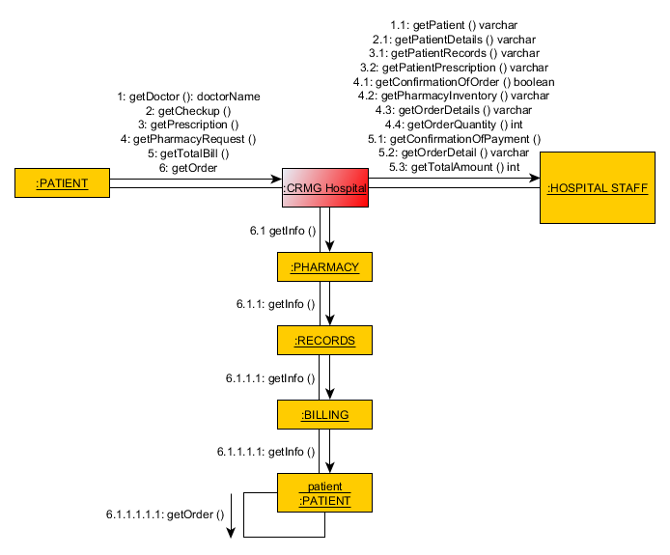**COMMUNICATION DIAGRAM**

**COMPONENT DIAGRAM**

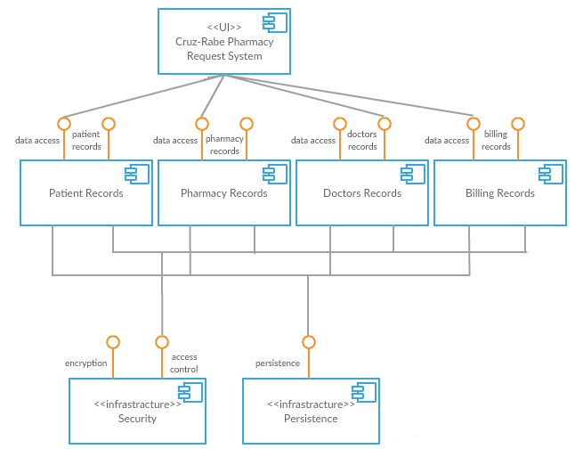

**COMPOSITE STRUCTURE FLOW**

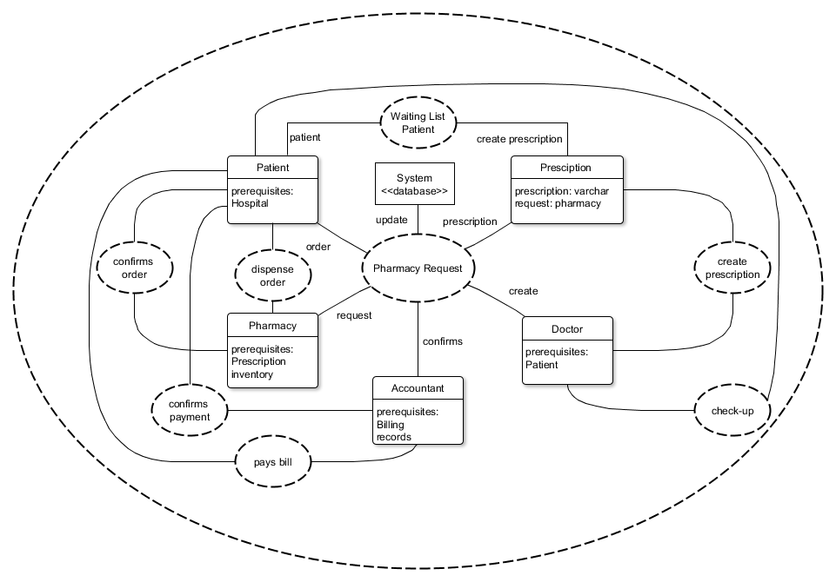

**CONTEXT FLOW DIAGRAM**

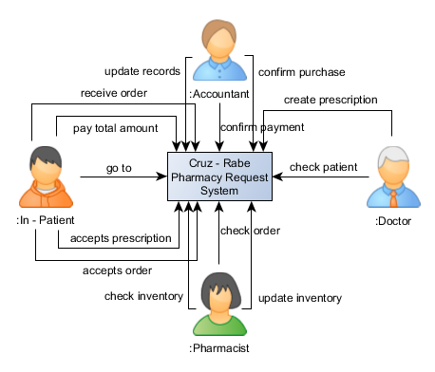

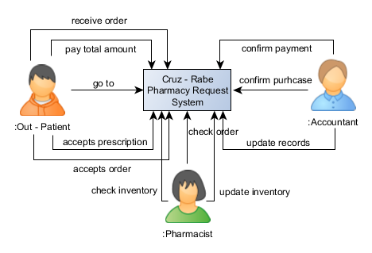

**DATA FLOW DIAGRAM**

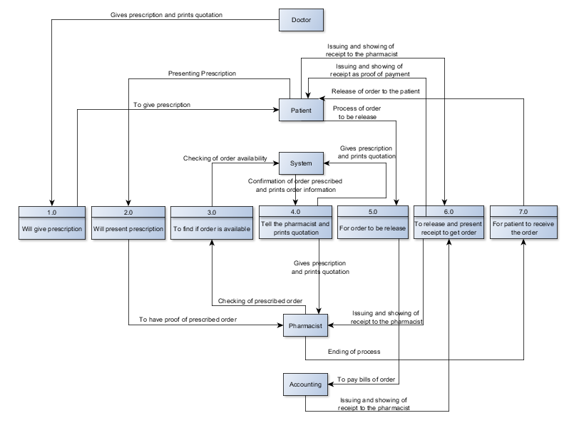

**DEPLOYMENT DIAGRAM**

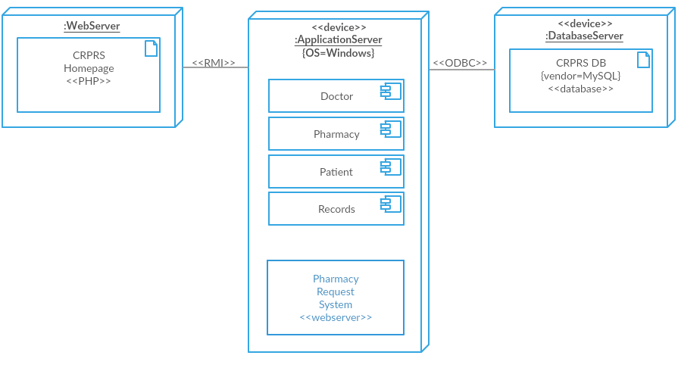

**INTERACTION OVERVIEW DIAGRAM**

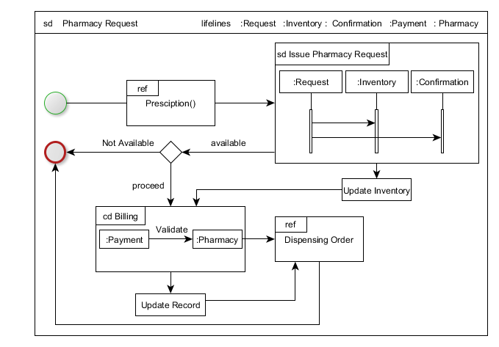

**OBJECT DIAGRAM**

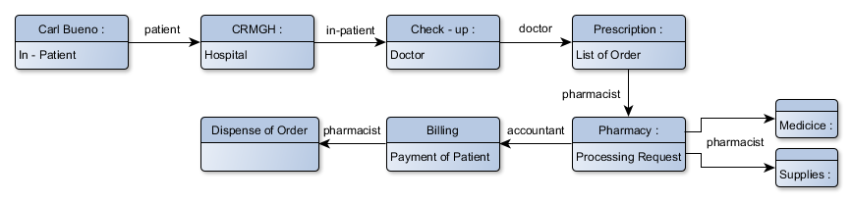

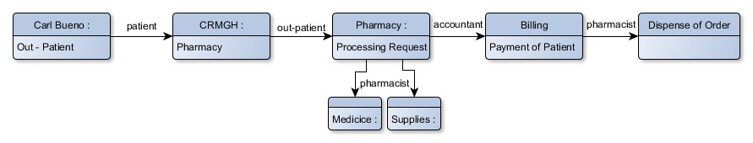

**PACKAGE DIAGRAM**

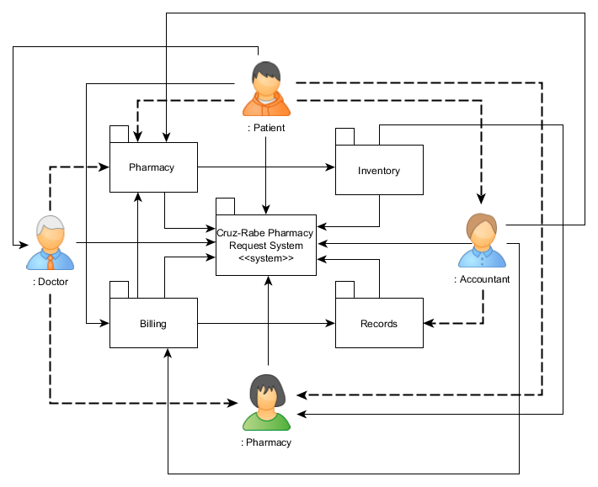

**SEQUENCE DIAGRAM**

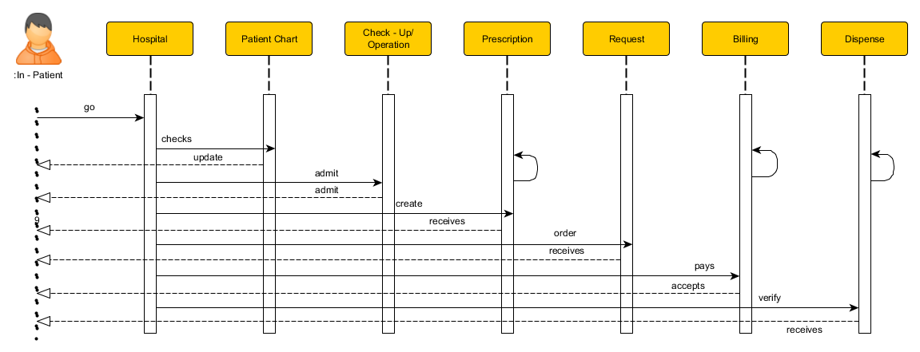

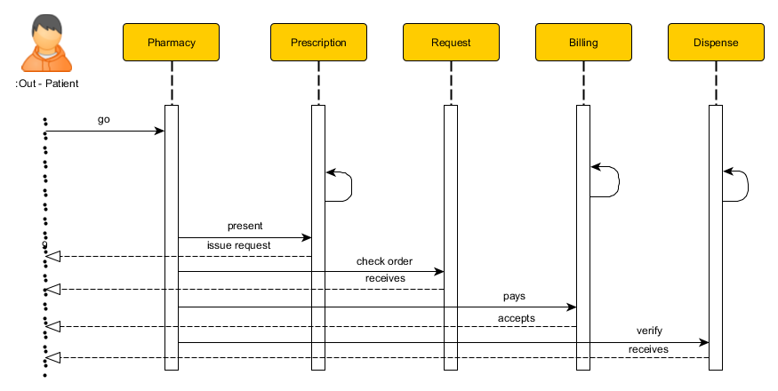

**STATE MACHINE DIAGRAM**

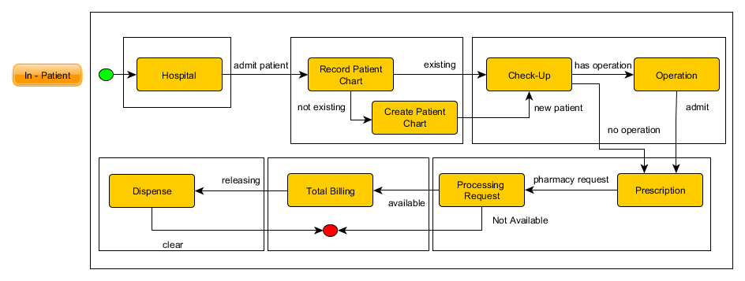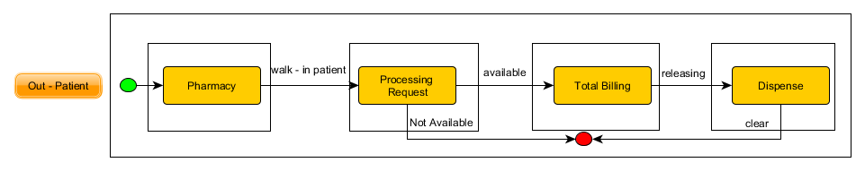

**TIMING DIAGRAM**

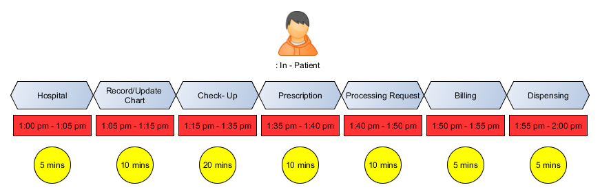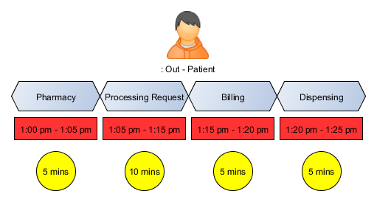

**USE CASE DIAGRAM**

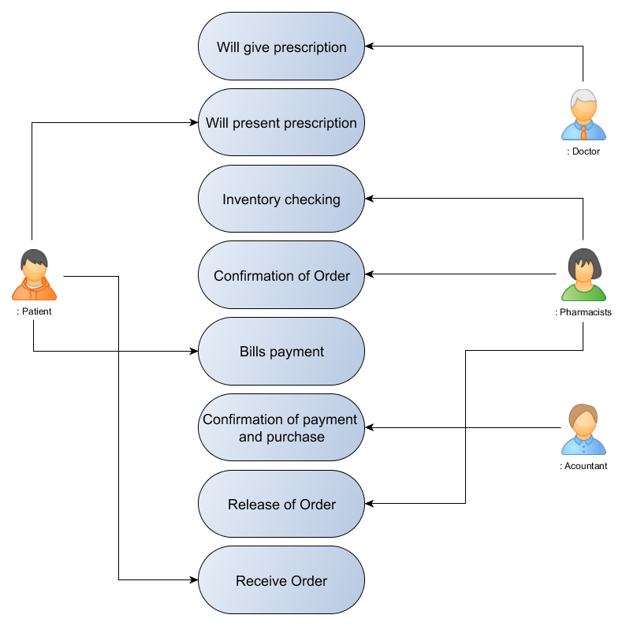

**Reference/s:**

* <http://projects2.apc.edu.ph/wiki/index.php/Project_-_Cruz-Rabe_Pharmacy_Request_System_%28CR-PRS%29_-106>
* <http://github.com>
* <http://moodle2.apc.edu.ph>
* <http://email.apc.edu.ph>
* <http://localhost/phpmyadmin>
* http://localhost/CRP
* <http://doh.gov.ph>
* <http://www.omnicell.com/About_Omnicell.aspx>
* <https://www.pioneerrx.com/web/pioneerrx>



**CARL DOMINIQUE P. BUENO**

07 Jones Street, Wawa, Taguig City

cpbueno@student.apc.edu.ph

+639366993325

**Education Background:**

June 2012 – Present **Asia Pacific College**

#3 Humabon Place, Magallanes, Makati City

*Bachelor of Science in Information and Technology Major in Mobile and Internet Technology*

June 2008 – March 2012 **Senator Renato Companero Cayetano Memorial Science and Technology**

**High School**

31st cor 51st Sts. Pamayanang Diego Silang, Ususan, Taguig City

June 2002 – March 2008 **Pillar of Truth Educational Foundation Inc.**

1632 M.L. Quezon Street, Taguig City

**Organizations:**

2014 **Philippine Red Cross**

Asia Pacific College

*Officer*

2012 **Junior Philippine Computer Society**

Asia Pacific College

*Member*

2010 **Philippine Robotics Club**

SRCCMSTHS

*Member*



**GLEN ROY D. ROSALES**

BCDA Centennial Village, Bldg 1-217, Western Bicutan,

Taguig City

[gdrosales@student.apc.edu.ph](mailto:gdrosales@student.apc.edu.ph)

0997-206-5165

**Educational Background:**

June 2013 – Present **Asia Pacific College**

#3 Humabon Place, Magallanes, Makati City

*Bachelor of Science in Information and Technology Major in Mobile and Internet Technology*

June 2009 – March 2013 **Fort Bonifacio High School**

J.P Rizal Ext., West Rembo, Makati City

June 2003 – March 2009 **Fort Bonifacio Elementary School**

J.P Rizal Ext., West Rembo, Makati City

**Organizations:**

2015 – 2016 **The Good People of Society**

*Former President/Member*